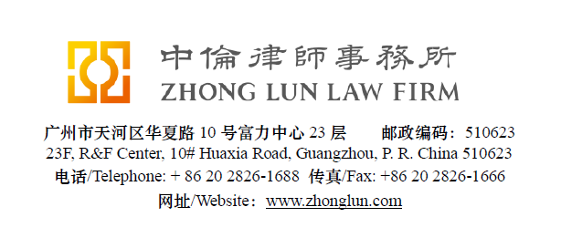

Invoice / 收款通知书

Date  日期 | 28/07/2019 | ZL Invoice Reference  中伦收款通知编号 | 079604-0001/001
Client  客户 |  | Raly Traffic Accessories Ltd.  Kibutz Mishmarot (Itzhaky Zone)  P.O. B 1359 Pardes Hana  37113 3711301 Israel
Subject Matter  事项 | General | Service Period  服务期限 | July 2019
Legal Fee  律师费 | USD 765 | Reimbursement  报销费用
Sum Now Due  总应付款 | USD 765

Please make the payment to the banks account as follows:
请将上述款项付至下列账户：

Account Number  账号 | 1209 0403 9310 502 | Swift Code  银行代码 | CMBCCNBS131
Account Name  账户名称 | Beijing Zhong Lun Law Firm Guangzhou Office  北京市中伦（广州）律师事务所
Bank Name  开户行 | China Merchants Bank, Guangzhou Branch, R&F Center Subbranch  招商银行广州分行富力中心支行
Address  地址 | 2/28F R&F Center, 10 Huaxia Road, Guangzhou, China  广州市华夏路10号富力中心2/28楼

Zhong Lun Law Firm 中伦律师事务所

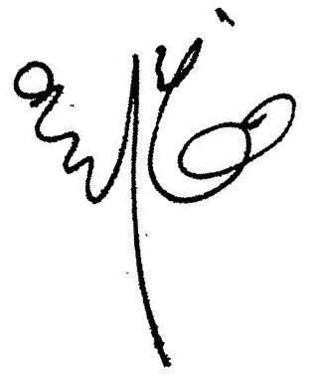

Charge Details/收费明细

To our Professional Charges for our service rendered in respect of the following:
中伦律师事务所就如下事宜提供了专业服务：

 | Service Provided  已提供之服务 | Cost (USD)  费用 (美元)
- 1. | Fixed legal fee for issuing the Letter of Demand to Drivemaster Co., LTD. | 765
 | Total/合计： | 765

Please kindly indicate the ZL Invoice Reference number on your bank processing document and provide us a copy of the bank confirmation for the payment. /请在银行付款单据上标明中伦收款通知编号，并向我方提供相关银行确认书。
Please pay equivalent foreign currency if a USD account is not available. /若未能支付美元，请支付等值外币。
Please indicate the FULL name in the bank advice and state the FULL name at the remark or note section on the bank advice./ 请在银行付款单据上列明全称并在汇款附言或备注栏填入收款人全称。

